EMPLOYEE MANAGEMENT SYSTEM
Day 3 KT Task Implementation Document

College Name : Velammal Institute of Technology

College Code : 1133

Student Name : JAGADEESHWARI N

Department : B.Tech – Artificial Intelligence & Data Science

Naan Mudhalvan (NM) ID: aut113323aia15

Phone Number : 6382193392

Email ID : jagadeeshwarinataraj98@gmail.com

Project Title: EMPLOYEE MANAGEMENT SYSTEM

GitHub Repository Link:

1. INTRODUCTION
This document explains the step-by-step process followed to implement the Day 3 KT Backend Task using Node.js and Express.js.
The task focuses on creating REST APIs for managing employee data, including GET, POST, PUT (single & multiple updates) and testing them using Postman.

2. OBJECTIVE OF DAY 3 KT TASK
The objective of this task is to:
- Understand backend API development using Node.js
- Implement RESTful routes
- Perform CRUD operations
- Handle multiple record updates
- Test APIs using Postman
- Push the code to GitHub

3. TECHNOLOGIES USED
- Node.js
- Express.js
- JavaScript
- Postman
- GitHub

4. STEP-BY-STEP IMPLEMENTATION PROCESS

Step 1: Create Project Folder
A new project folder named employee-management was created.
mkdir employee-management
cd employee-management

Step 2: Initialize Node.js Project
npm init -y
This creates a package.json file.

Step 3: Install Express.js
npm install express

Step 4: Create Project Structure
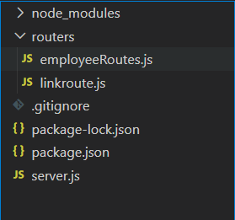
employee-management/
│
├── server.js
├── routes/
│ └── employees.js

Step 5: Create Server File (server.js)
- Express server initialized
- JSON middleware enabled
- Routes connected

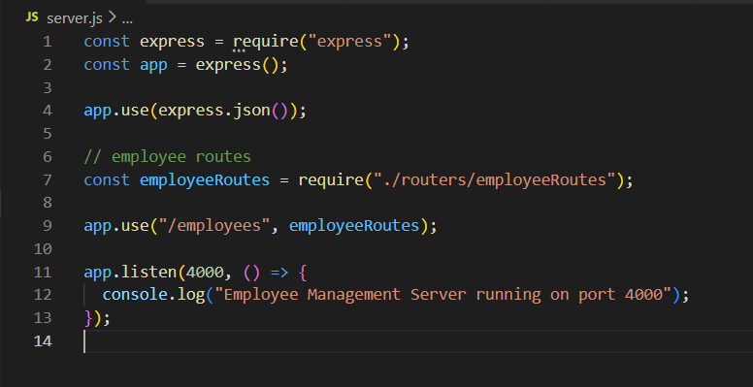

Step 6: Create Employee Routes (employees.js)
In-memory employee data is used.

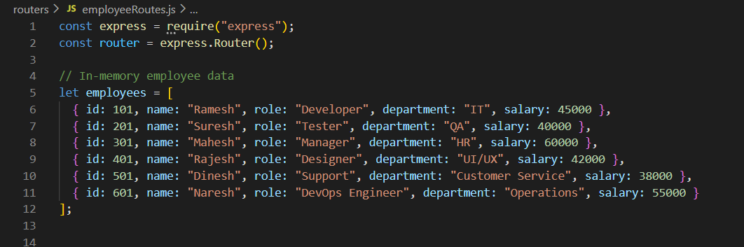

Step 6.1 :executing the CRUD operations

const express = require("express");
const router = express.Router();

// In-memory employee data
let employees = [
{ id: 101, name: "Ramesh", role: "Developer", department: "IT", salary: 45000 },
{ id: 201, name: "Suresh", role: "Tester", department: "QA", salary: 40000 },
{ id: 301, name: "Mahesh", role: "Manager", department: "HR", salary: 60000 },
{ id: 401, name: "Rajesh", role: "Designer", department: "UI/UX", salary: 42000 },
{ id: 501, name: "Dinesh", role: "Support", department: "Customer Service", salary: 38000 },
{ id: 601, name: "Naresh", role: "DevOps Engineer", department: "Operations", salary: 55000 }
];

// ✅ GET – All employees
router.get("/", (req, res) => {
res.json(employees);
});

// ✅ GET – Employee by ID
router.get("/:id", (req, res) => {
const id = parseInt(req.params.id);
const employee = employees.find(emp => emp.id === id);

if (!employee) {
return res.status(404).json({ message: "Employee not found" });
}

res.json(employee);
});

// ✅ POST – Add single or multiple employees
router.post("/", (req, res) => {
const data = req.body;

if (Array.isArray(data)) {
employees.push(...data);
} else {
employees.push(data);
}

res.json({
message: "Employee(s) added successfully",
employees
});
});

// ✅ PUT – Update MULTIPLE employees at once
router.put("/", (req, res) => {
const updates = req.body; // expecting array

if (!Array.isArray(updates)) {
return res.status(400).json({
message: "Request body must be an array"
});
}

let updatedEmployees = [];
let notFound = [];

updates.forEach(update => {
const index = employees.findIndex(emp => emp.id === update.id);

if (index !== -1) {
employees[index] = { ...employees[index], ...update };
updatedEmployees.push(employees[index]);
} else {
notFound.push(update.id);
}
});

res.json({
message: "Multiple employees updated",
updatedEmployees,
notFoundIds: notFound
});
});

// ✅ DELETE – Remove employee by ID
router.delete("/:id", (req, res) => {
const id = parseInt(req.params.id);

const index = employees.findIndex(emp => emp.id === id);

if (index === -1) {
return res.status(404).json({ message: "Employee not found" });
}

const deletedEmployee = employees.splice(index, 1);

res.json({
message: "Employee deleted successfully",
employee: deletedEmployee[0]
});
});

module.exports = router;
5. Running the Project

Backend:
Run Backend
cd backend
npm start
Backend runs at:
http://localhost:4000/employees

6. API IMPLEMENTATION DETAILS

GET – Fetch All Employees
Endpoint:
GET /employees
Purpose:
Fetch all employee records.
Postman Setup
- Method: GET
- URL: http://localhost:4000/employees

POST – Add Single or Multiple Employees
Endpoint:
POST /employees
Functionality:
- Accepts both single object and array
- Adds employees to the data store

PUT – Update Single Employee
Endpoint:
PUT /employees/:id
Functionality:
- Updates employee details using ID
- Supports partial updates

PUT – MULTIPLE EMPLOYEE UPDATE (KEY TASK)
Endpoint:
PUT /employees
Description:
This API updates multiple employees in a single request using an array of objects.
Sample Request Body:
[
{ "id": 1, "salary": 32000 },
{ "id": 2, "dept": "Admin", "salary": 45000 }
]
Logic Used:
- Loop through request array
- Match employee by ID
- Update only provided fields
This demonstrates real-world backend data handling.

7. TESTING USING POSTMAN
Postman was used to test all APIs.
Tests Performed:
- GET → View all employees
- POST → Add multiple employees
- PUT → Update single employee
- PUT → Update multiple employees

SCREENSHOTS OF THE TESTING IN POSTMAN:
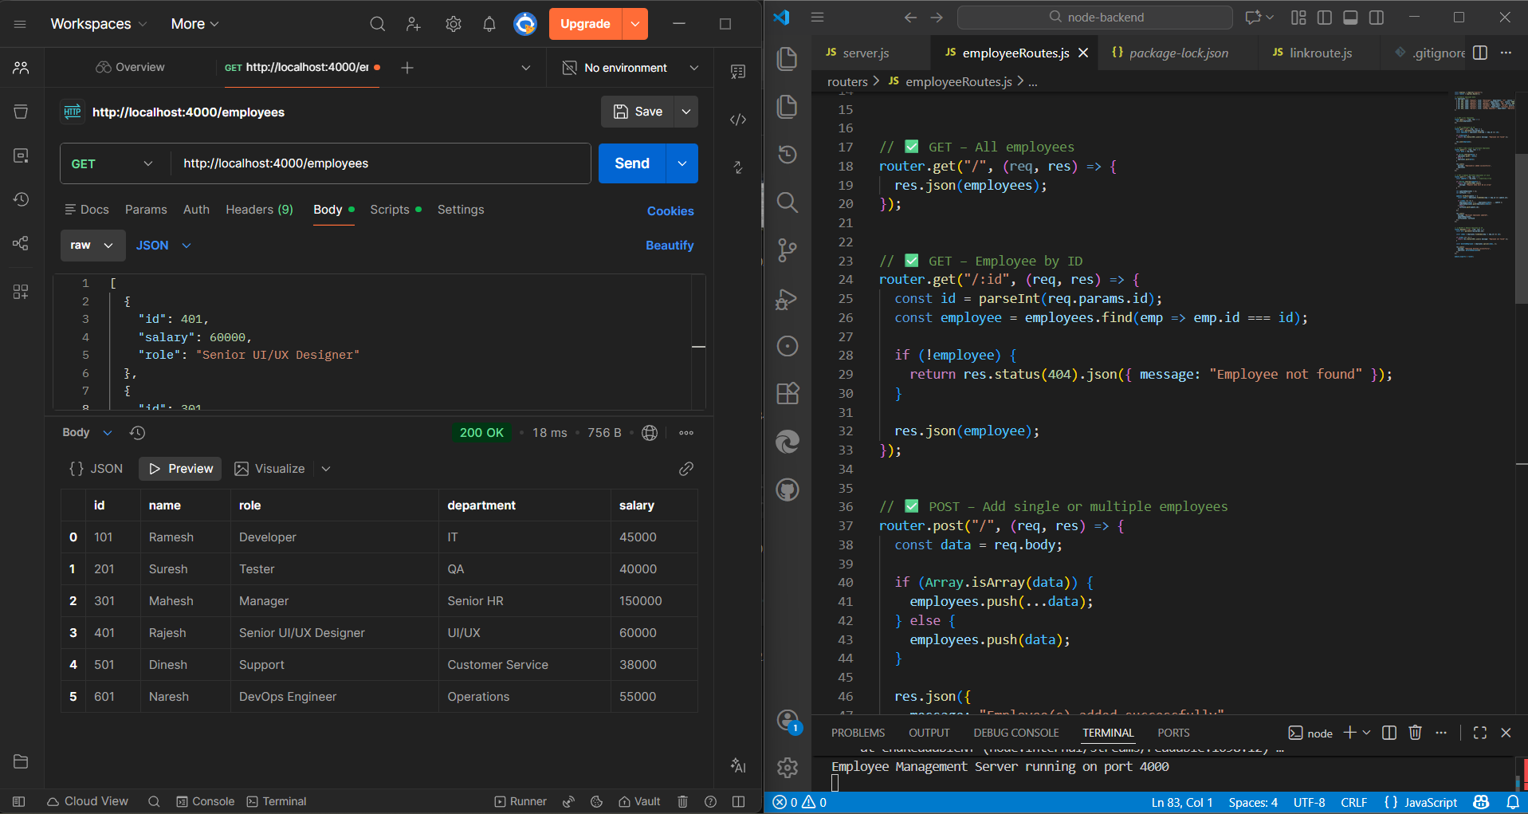
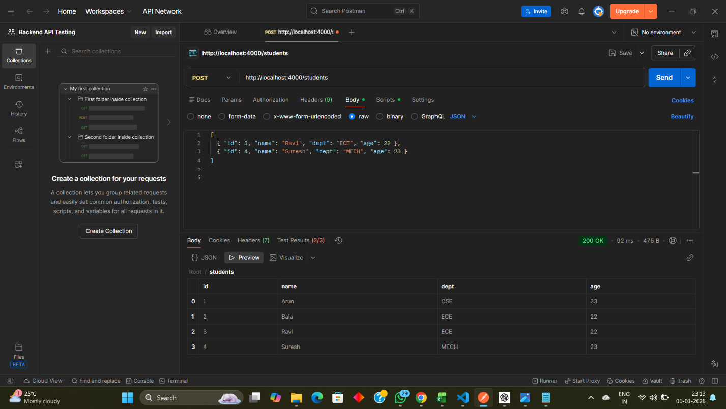

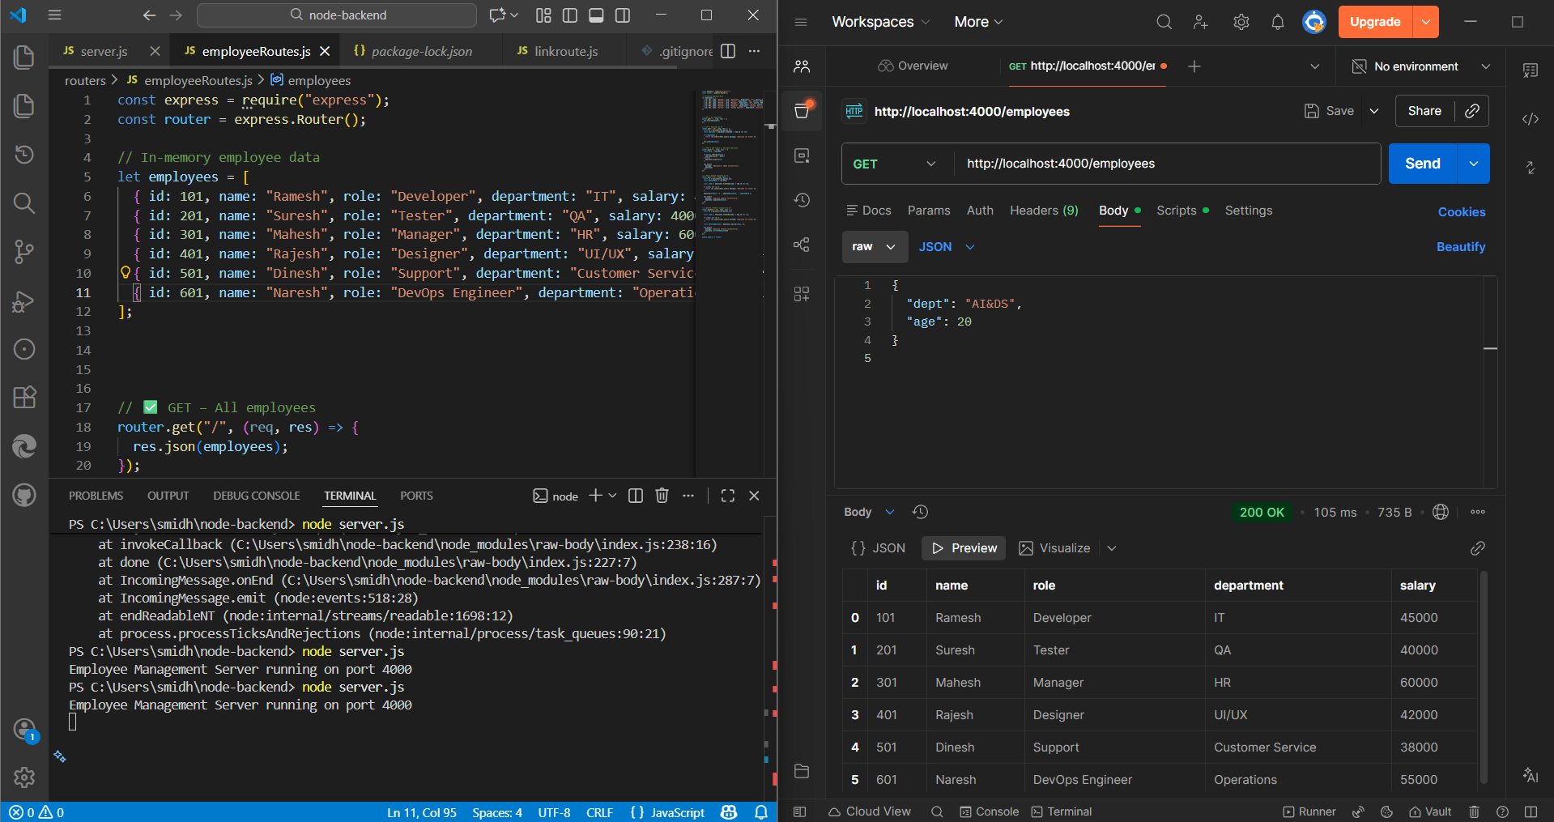
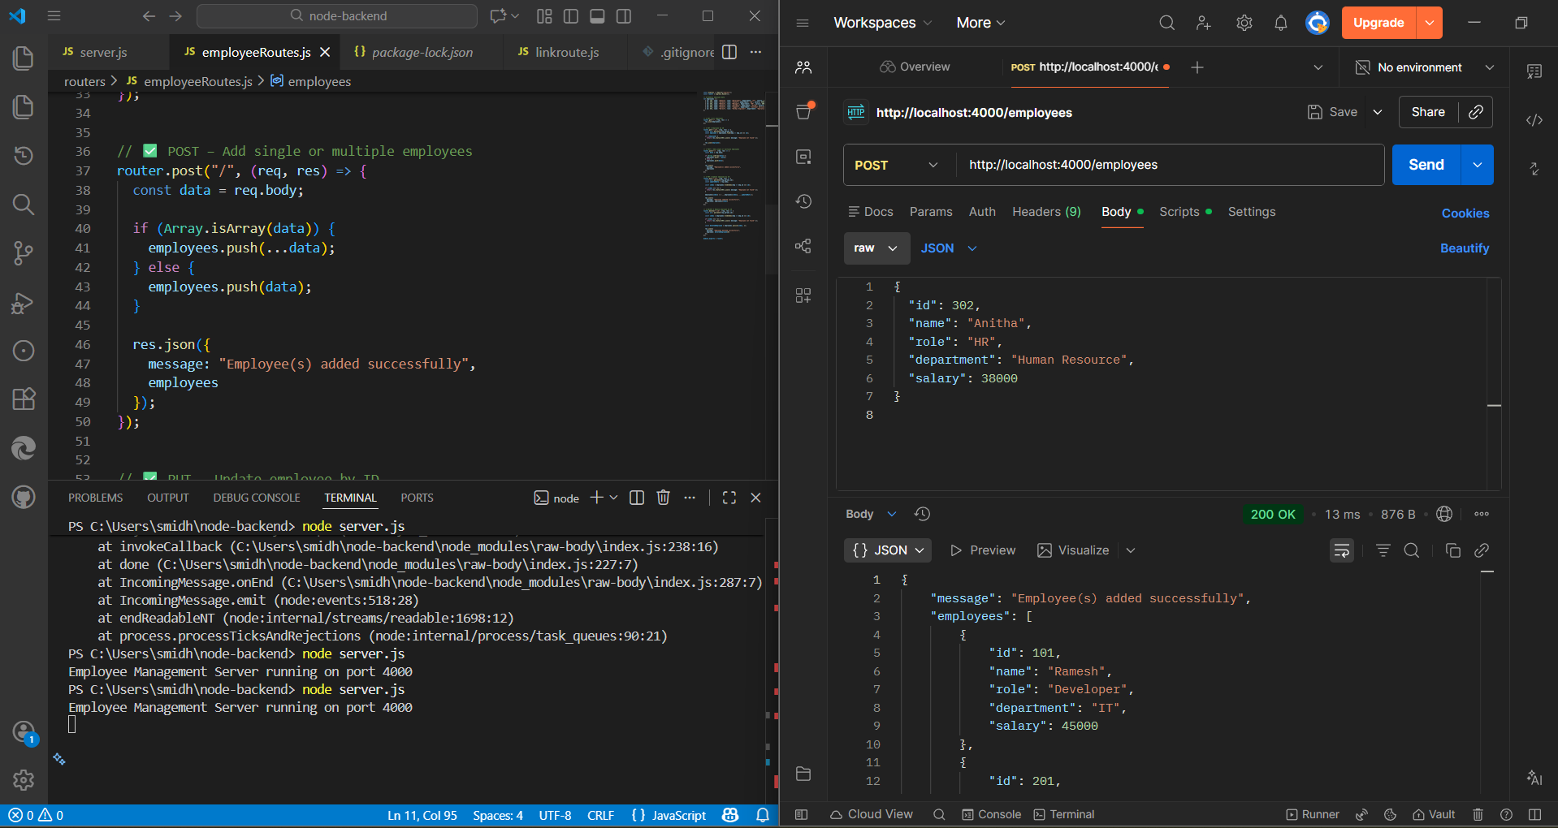

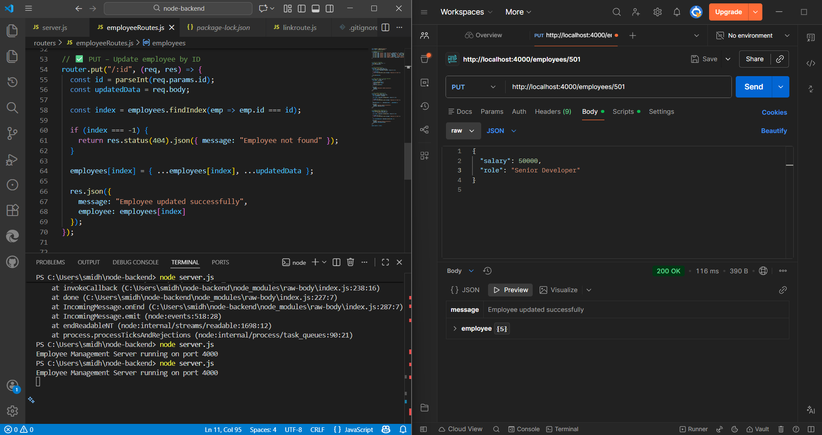
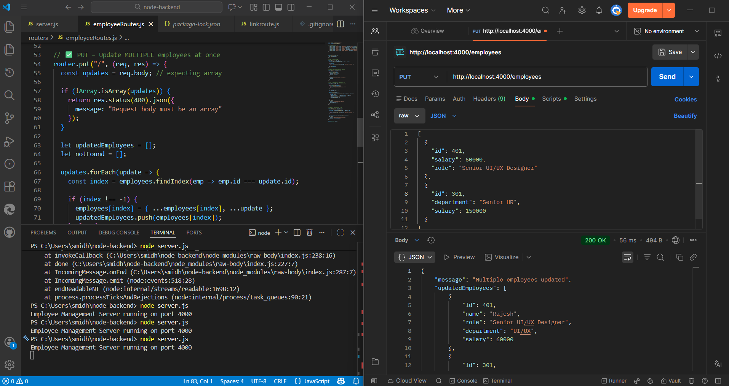

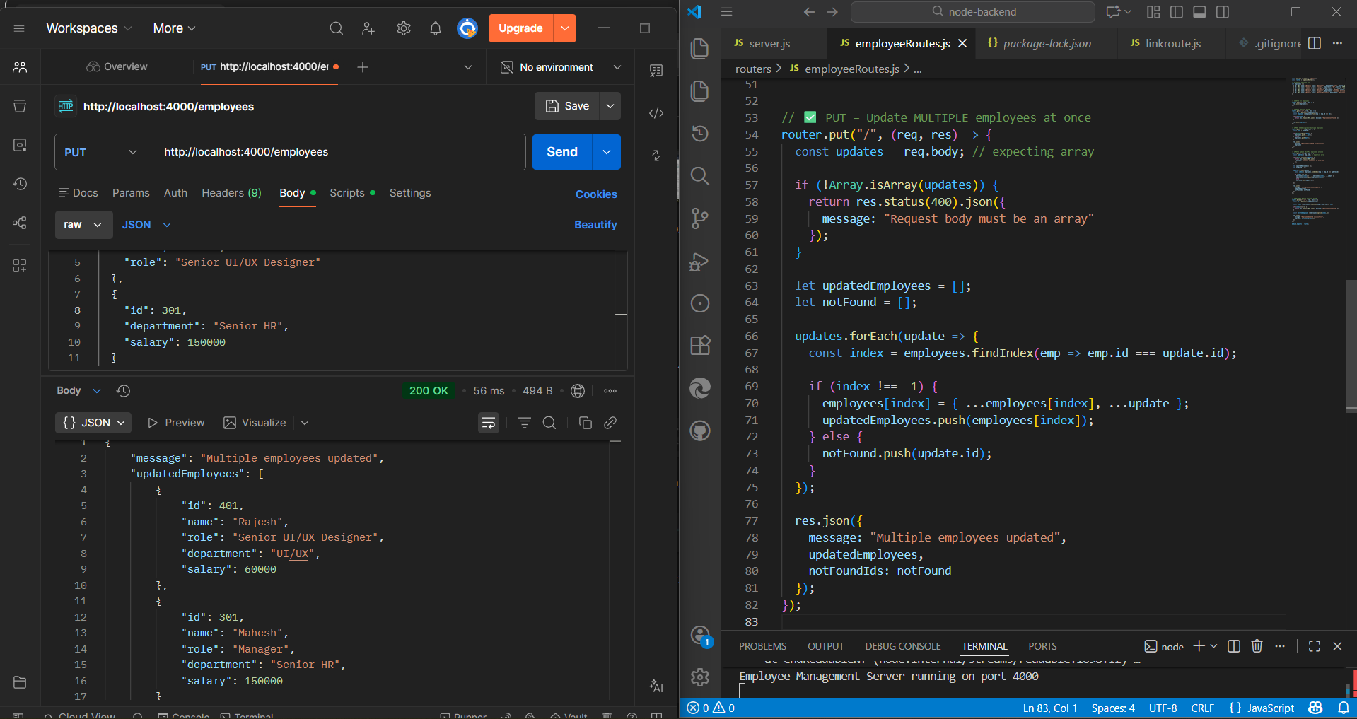

8. GITHUB REPOSITORY LINK
The complete Day 3 KT task code is pushed to GitHub.
🔗 GitHub Repository Link:

9. RESULT
Thus, the Day 3 KT Backend Task was successfully completed using Node.js and Express.js.
All required APIs including multiple PUT update were implemented, tested, and documented.

10. CONCLUSION
This task improved understanding of:
- Backend routing
- REST API design
- Handling multiple data updates
- API testing using Postman
- GitHub version control

11. FUTURE ENHANCEMENTS
- Database integration (MongoDB)
- DELETE API
- Validation middleware
- Authentication

